|  |  |  |
| --- | --- | --- |
|  |  |  |
|  | IST 659 DBMS Final Group Project |  |
|  |  |  |

Group no: 17

Group Members: Piyush Khedkar (346396263)

Harish Reddy Yedulla (446306990)

Chinmay Maganur (370801446)

**Project Goals:**

The main objective of our project is to create a database for supply-chain management to help suppliers continuously monitor the statistics and help the customers.

* Monitoring and managing the records for warehouses, stock, orders, etc.
* Allowing the suppliers to interact with UI to obtain all the necessary statistics and live insights
* The UI will also keep updating to show accurate information about all the commodities for the buyers to place and modify their orders accordingly

**Project Specifications:**

* Entity Relationship Data Requirements/Business Rules (ER Diagram)
* Conceptual Data Model
* Logical Data Model
* SQL/Up/Down Script to create/drop tables, modify tables & keys constraints
* User Stories
* External data model satisfying user stories
* User Interface Design

**ER-Sheet:**

**Conceptual Model:**

**Logical Model:**

# **Up/Down Script:**

User Stories:

Buyer-User Stories:

* View Commodities
* Place an Order
* Order History

Supplier-User Stories:

* View Warehouses
* View Pending Orders

**Basic UI Flow Design:**

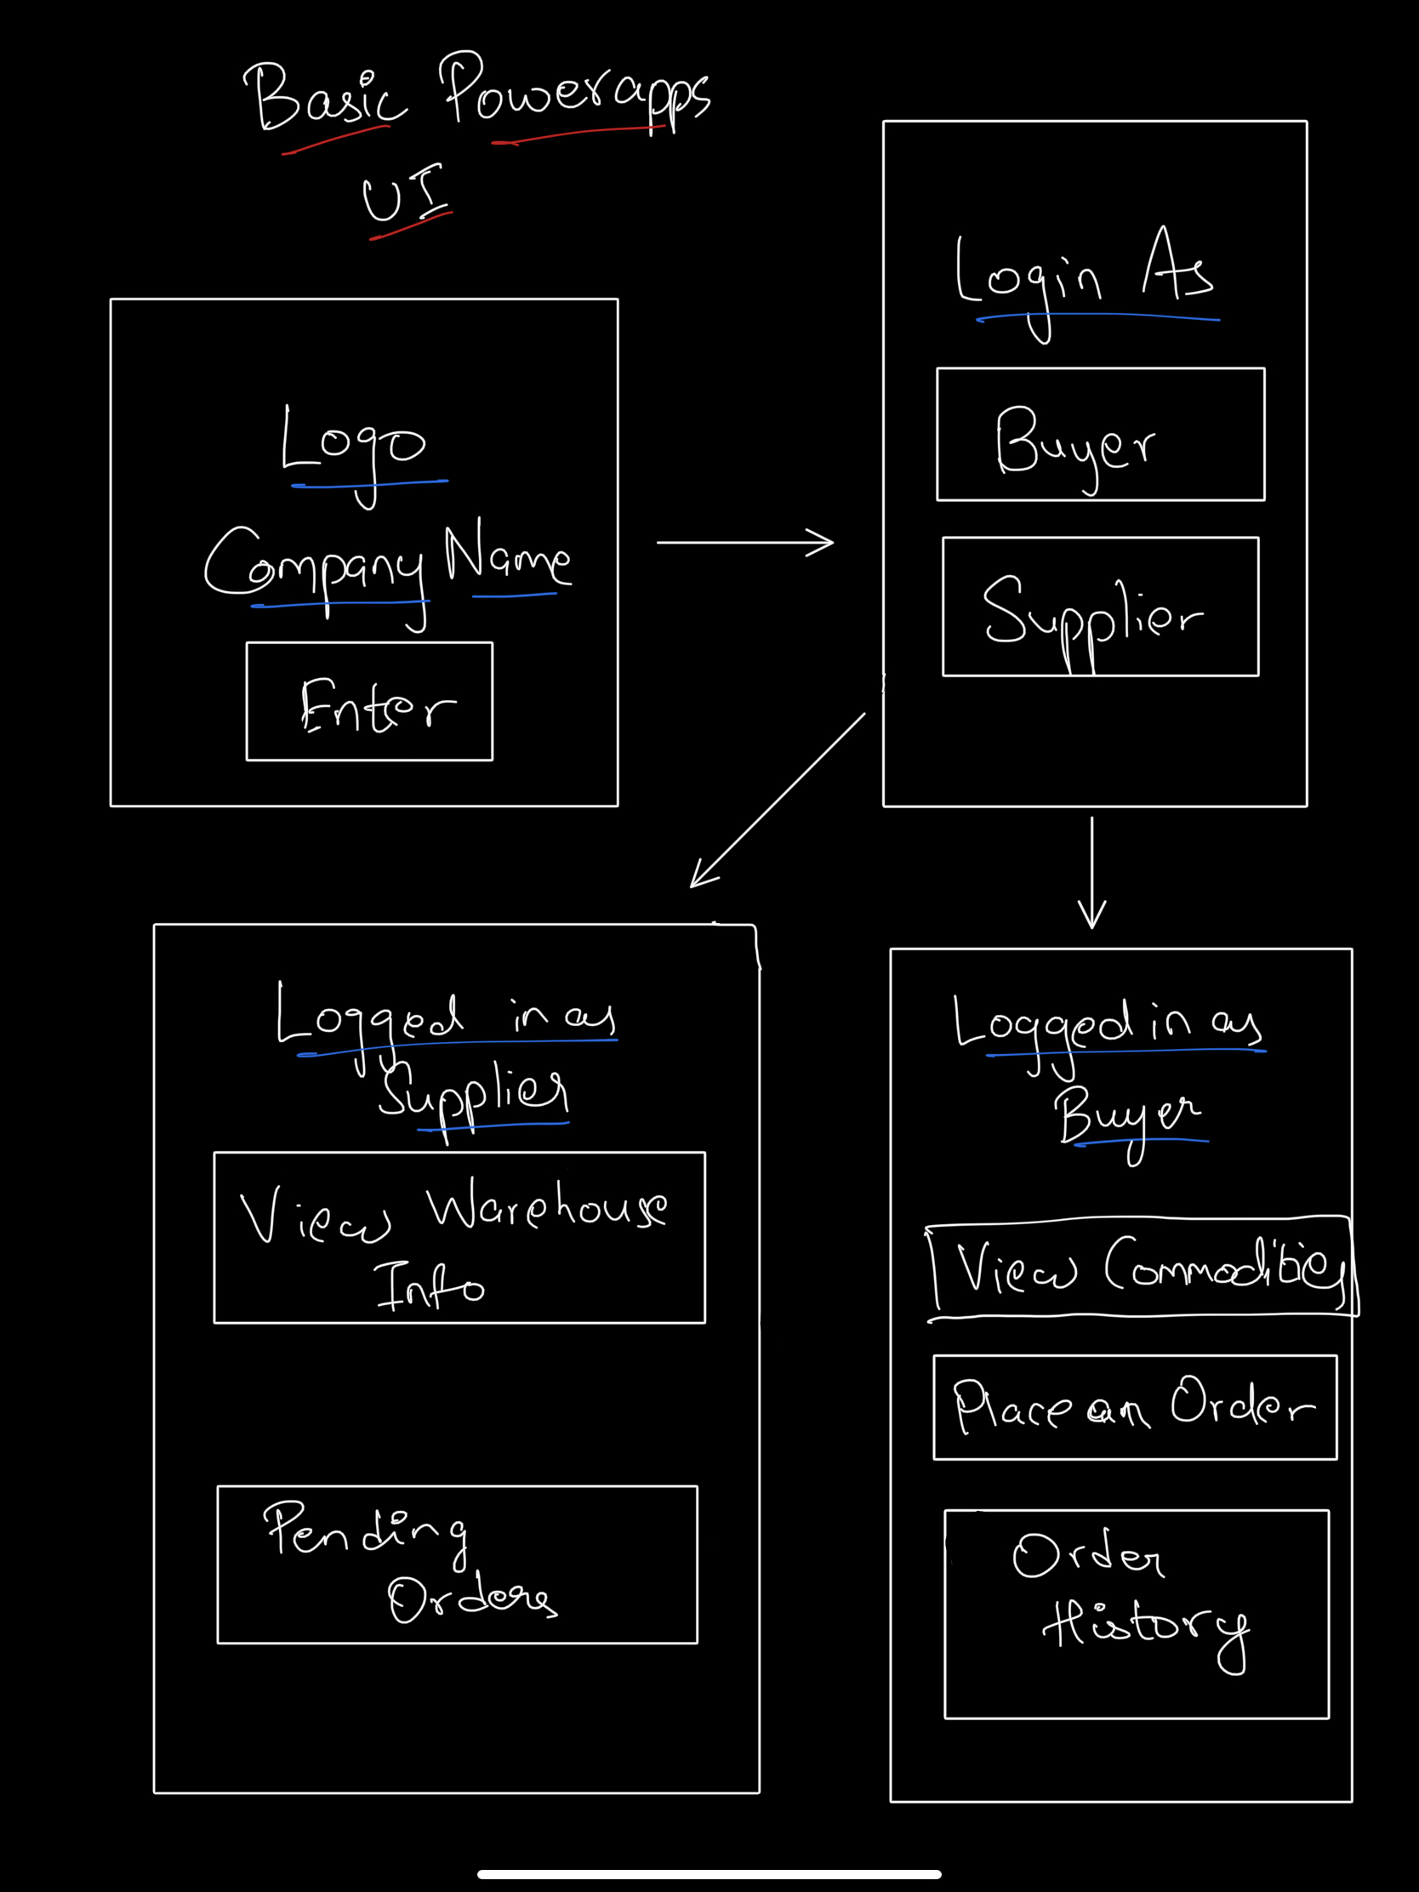

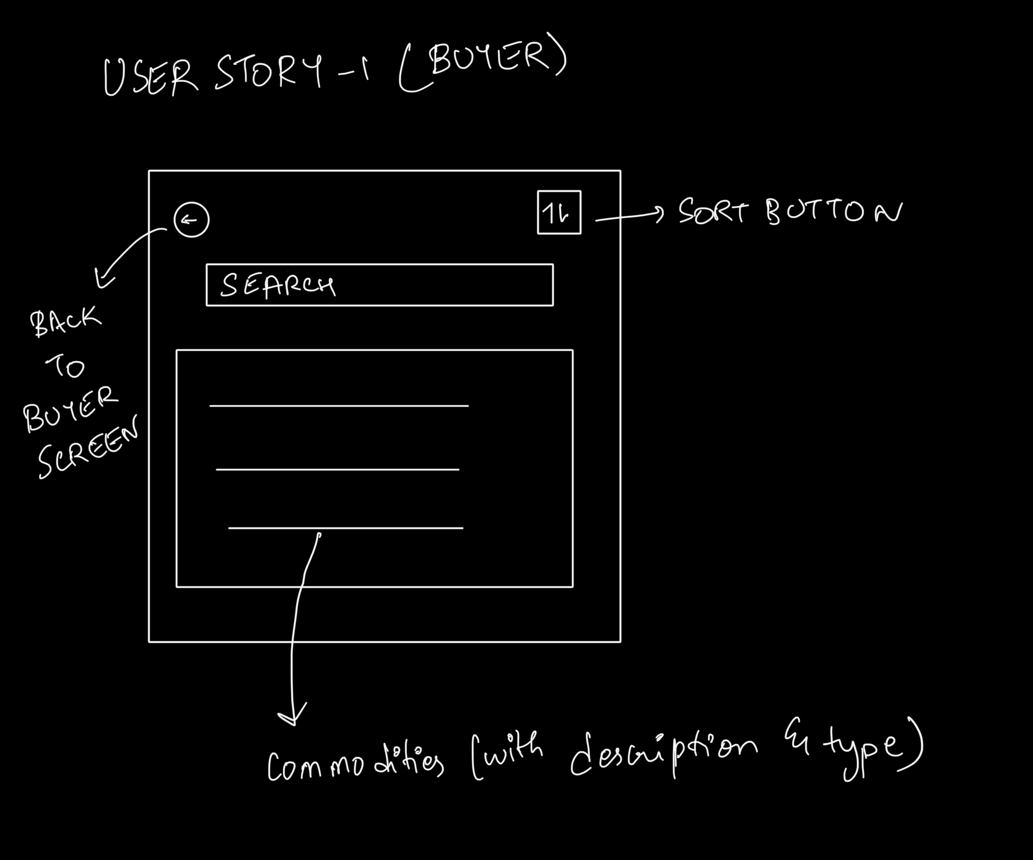

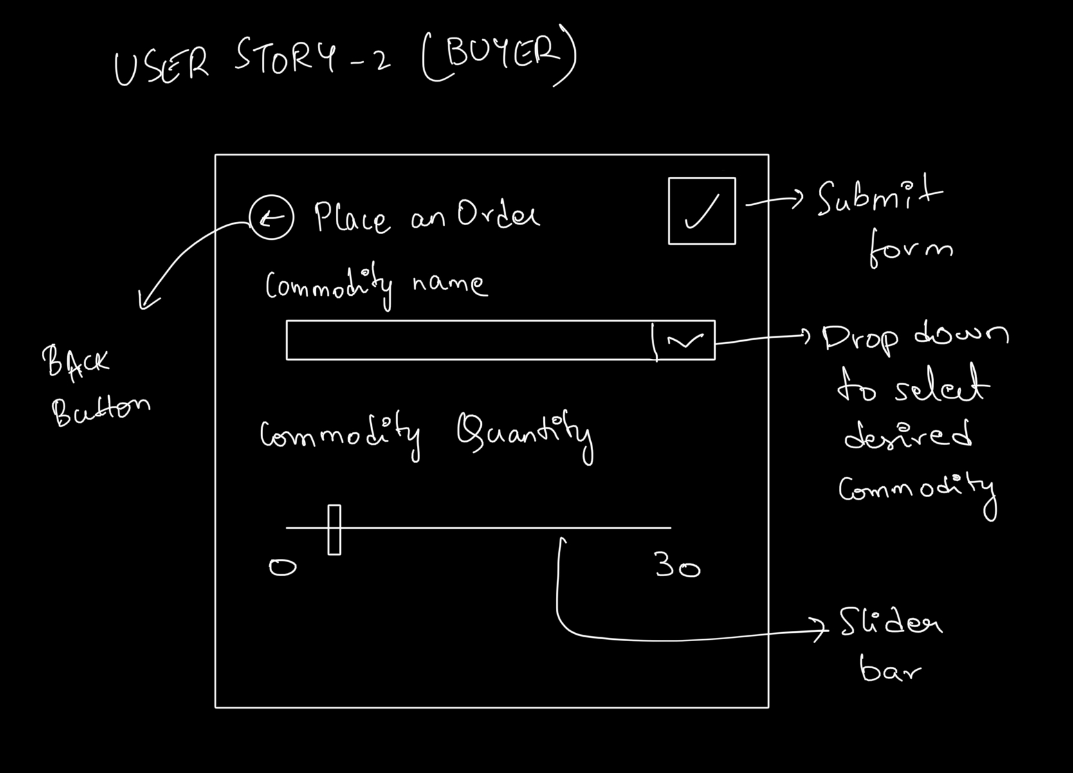

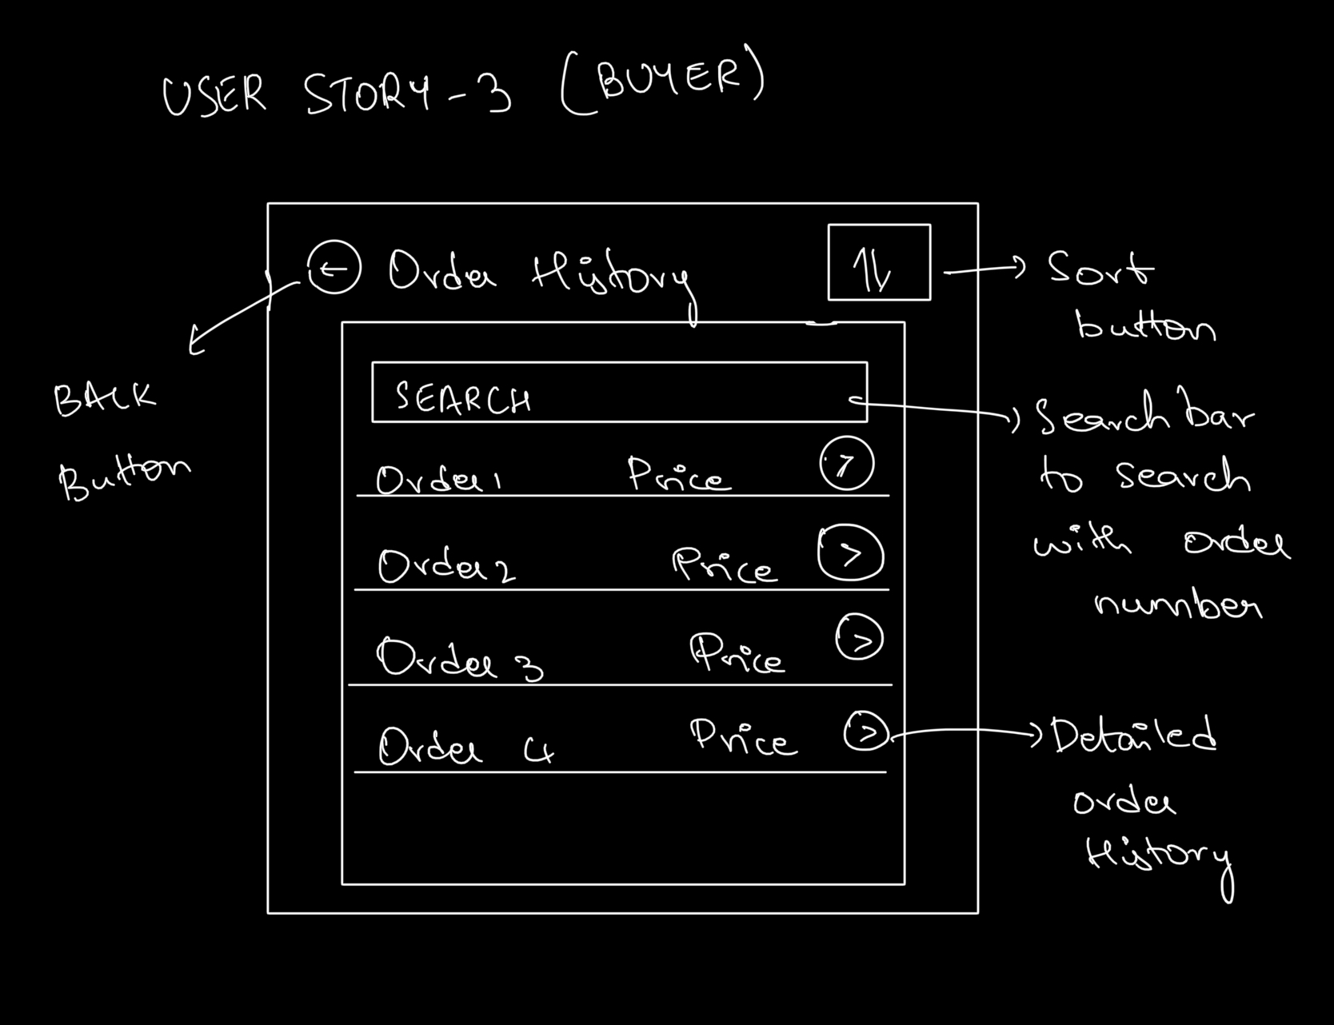

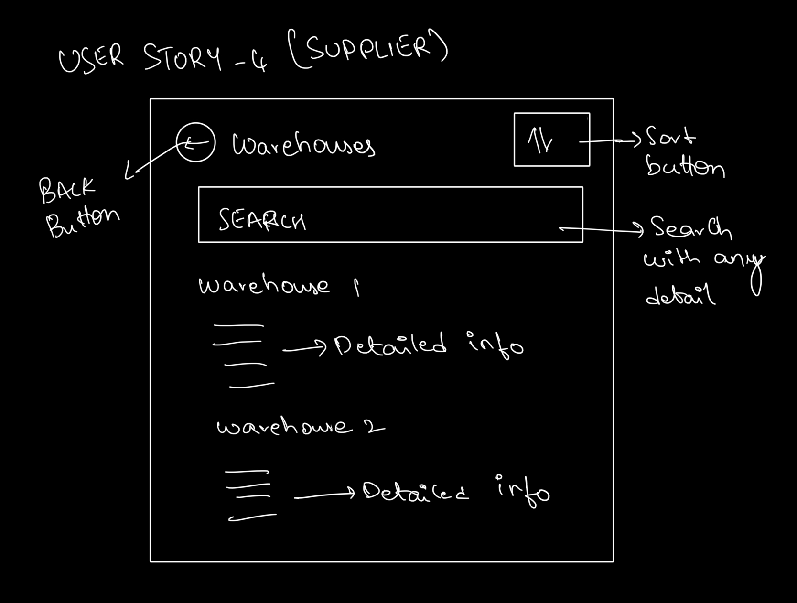

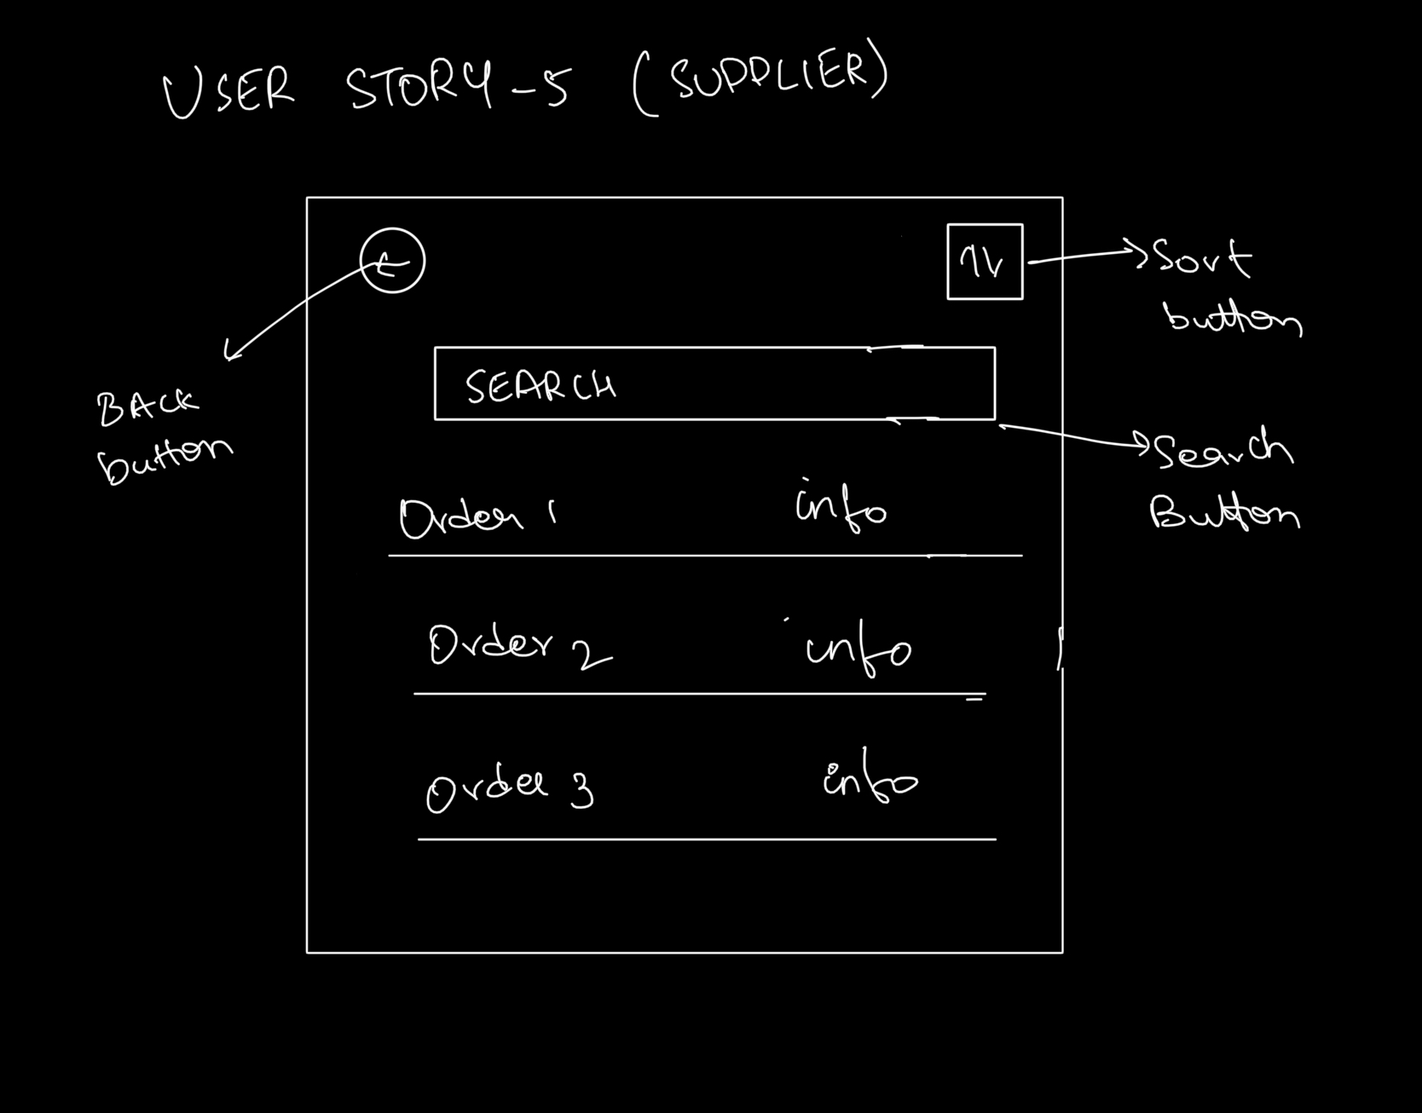

**App Demo:**

[**Video working link**](https://www.youtube.com/watch?v=c_gAdjZDQw4&feature=youtu.be)

[**Reflection video**](https://www.youtube.com/watch?v=x-44UnweZ0s)

**Document Links:**

**Time Log sheet**